 | “GREAT ROUTES IN THE MIDDLE AGE AND THEIR SYMBOLOGY”  Nr. 2016-1-ES01-KA219-025035_3 | 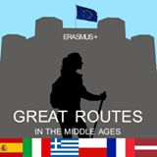
Alīna Zaharevska, Latvia

Distances between the Hanseatic cities were large, so the people had to spend a long time on the way, for example, at the middle ages the goods from Riga only after about two months received Brig, to other cities the goods could travel for a year.
Traveling in the middle Ages was a dangerous and complex activity. Without the mundane problems such as ignorance of lodging and food, an important question was safety. Always there were robbers or a pirates’ attack possibility so traders had to think about their safety by themselves.
Fogt Albert from Brinkena (Albert von Brinkena, ruler 1371-1375) who was an important person from Livonian branch of German Order in 1374th year asked the Livonian Master to think about the safety of traders’ movement in order to allow them to follow the free trading.
In the middle Ages the Crusaders from Germany brought the Christian faith to Latvia and built churches. The German merchants followed them. Therefore, distance units from Germany were taken to Latvia.
In the Indriķa Chronicle (IH in 1993, I, 6; 337-339) Ikšķile (Ickesculle) is mentioned as the first German traders and crusaders’ support fortification where was built a stone castle. If the distance from the Gulf of Riga to Ikšķile was six miles, the castle, which was located in the plain, just from the river Daugava bank could look like built on the hill.

During the Middle Ages in Livonia distance was measured in German geographical miles (1 mile = 7.42 km)

In the middle ages there were used the following distances:
One-day distance is a historical unit of distance. It came to Europe with the first trade routes. And that sign was used until the 19th century till the birth of motorized transport vehicles. It is a distance that can be gone with a horse-drawn carriage within one day if the route is well known. Depending on the surroundings and the roads it was about 40km. In the laws of Cistercian monks’ order was said that the monastery farms had to be reached within a single day. Since the beginning there were built the one day distance fortifications near the roads, that later became fortresses/castles. In a half day distance there were often made fortified seats from which were systematically colonized the land.
If today is used the phrase “a one-day distance”, then it is already dependent on the speed of vehicle. It can be from 10 to 10,000 km (air traffic).
Hour walk / hour journey is the journey, which can be gone by traveller in one hour.
Man can usually (walking a certain pace) walk one kilometre in 12-15 minutes; it is about 4-5 km per hour. 3 ¾ to 5 km is about half a mile (geographical mile is 7.4 miles = the ground mile 10km)
1 hour ride - it is between 2/3 and ¾ miles. It depends on the horse's pace.
Carriage’s hour drive distance. If the carriage drives along a good path, then it was on average 15 km.
The difference between the distance of hours and one-day trips is historically defined 2/3. So 10 hours ride corresponds to 14-15 hours walk.
Modern versions:
Car hour - it is clearly shown by the navigation device. It depends on speed, position, street condition.
Bus hour in public transport is lower than car hour.
Flight hour
Walking pace is important when planning routes for mountaineering.
In a minute you can walk 80-100 m. The distance is used for tourism.

vehicle | era | [km/h] | features
Walker, animal, cargo carrier | any | 3¾  5 | 10 hours walk, 1day distance approximately 40 km in plain
Horse ride |  | 6  10 | 80 km: in sport nowadays max. 160 km
bicycle | nowadays | 15-30
Moped | nowadays | 25
mail Victoria | 1700 | 2 | 20–30 km/a day
mail Victoria | 1800 | 3
mail Victoria | 1815 | 4
mail Victoria | 1830 | 6
mail Victoria | 1850 | 10 | 100–120 km/a day
railroad  (Horse-drawn Bani) | 1840 | 12  15 | 128 km/a day – traffic lines
Railway (steam) | 1850 | 35
Railway | 1870 | 50
Railway | 1910 | 90
Railway | 1930 | 120
Railway (diesel / electric) | 1980 | 125
Railway | 2009 | 310 | express train, 924 km
Metro | 1950 | 20-30
Car | 1905 | 15
Car | 1940 | 50
Car | nowadays | apm. 60
Sailing ship/galleon |  | 18
Steamship | 1840 | 16 | )
Steamship | 1950 | 64
Motor ship | nowadays | 45
airplane | 1930 | 150-400
airplane | nowadays | 850

Distance from Hanseatic city Riga – to Hanseatic”queen” Lübeck
vehicle | h | km | cost
ferry Ventspils_ Travemunde | 24h | 826,00km
Ferry: Liepāja Travemunde | 27h | 728,04 km | 32 euro for passenger
airplane Rīga –Hamburga | 2 h 5 min | 1499,34 km | 69 euro
car Rīga-Luebeck | 17 h 7min  16 h 23 min | 1398km  1497km
bus | 24 h 50 min | 1497km | 109 euro
train | 48 h | 1929.31 km

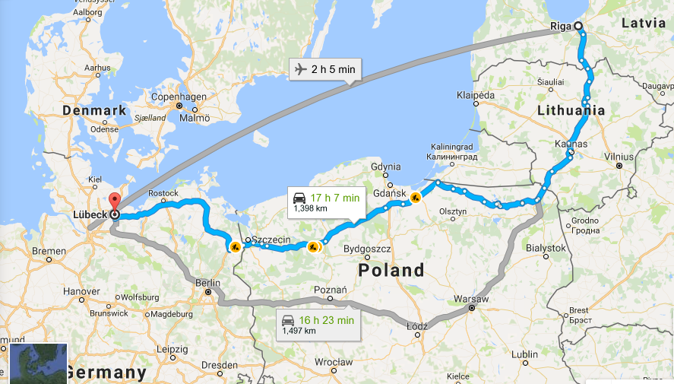
Distance: approximately. 600 nautical miles in 7 days

Sources:
http://www.aveline.lv/site/articles/category/lv/libeka
https://de.wikipedia.org/wiki/Tagesreise
https://de.wikipedia.org/wiki/Wegstunde
https://de.wikipedia.org/wiki/Reisegeschwindigkeit

